CS 255 System Design Document Template

This template lays out all the different sections that you need to complete for Project Two. Each section has guidance to prompt your thinking. You will need to continually reference the interview transcript as you work to make sure that you are addressing your client’s needs. There is no required length for the final document. Instead the goal is to complete each section based on what your client’s needs are. Remove this note when you are finished, and replace all bracketed text with the relevant information.

UML Diagrams

UML Use Case Diagram

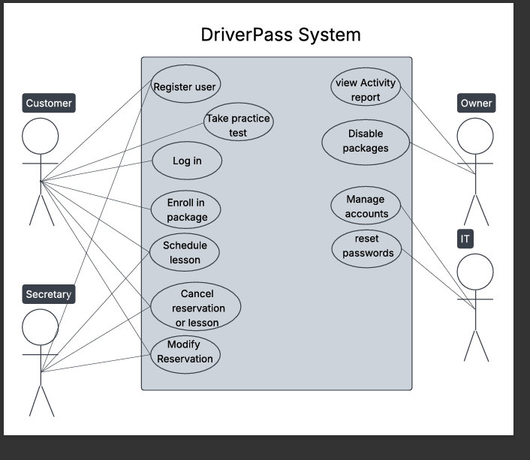

UML Activity Diagrams
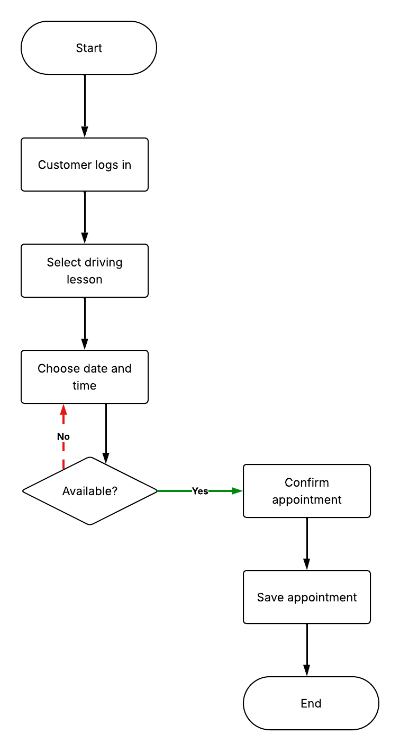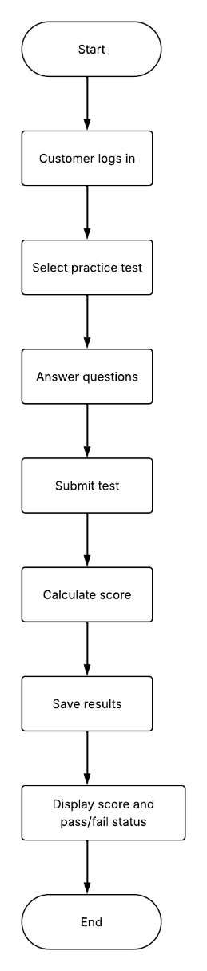

UML Sequence Diagram
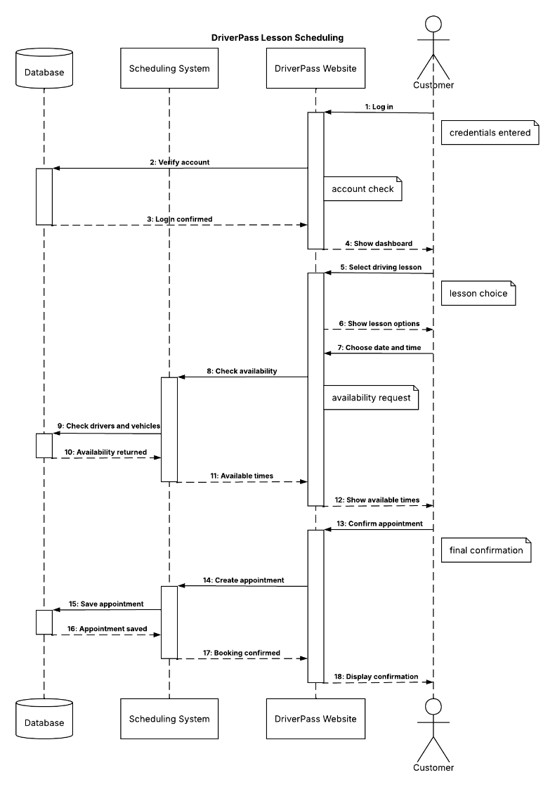

UML Class Diagram
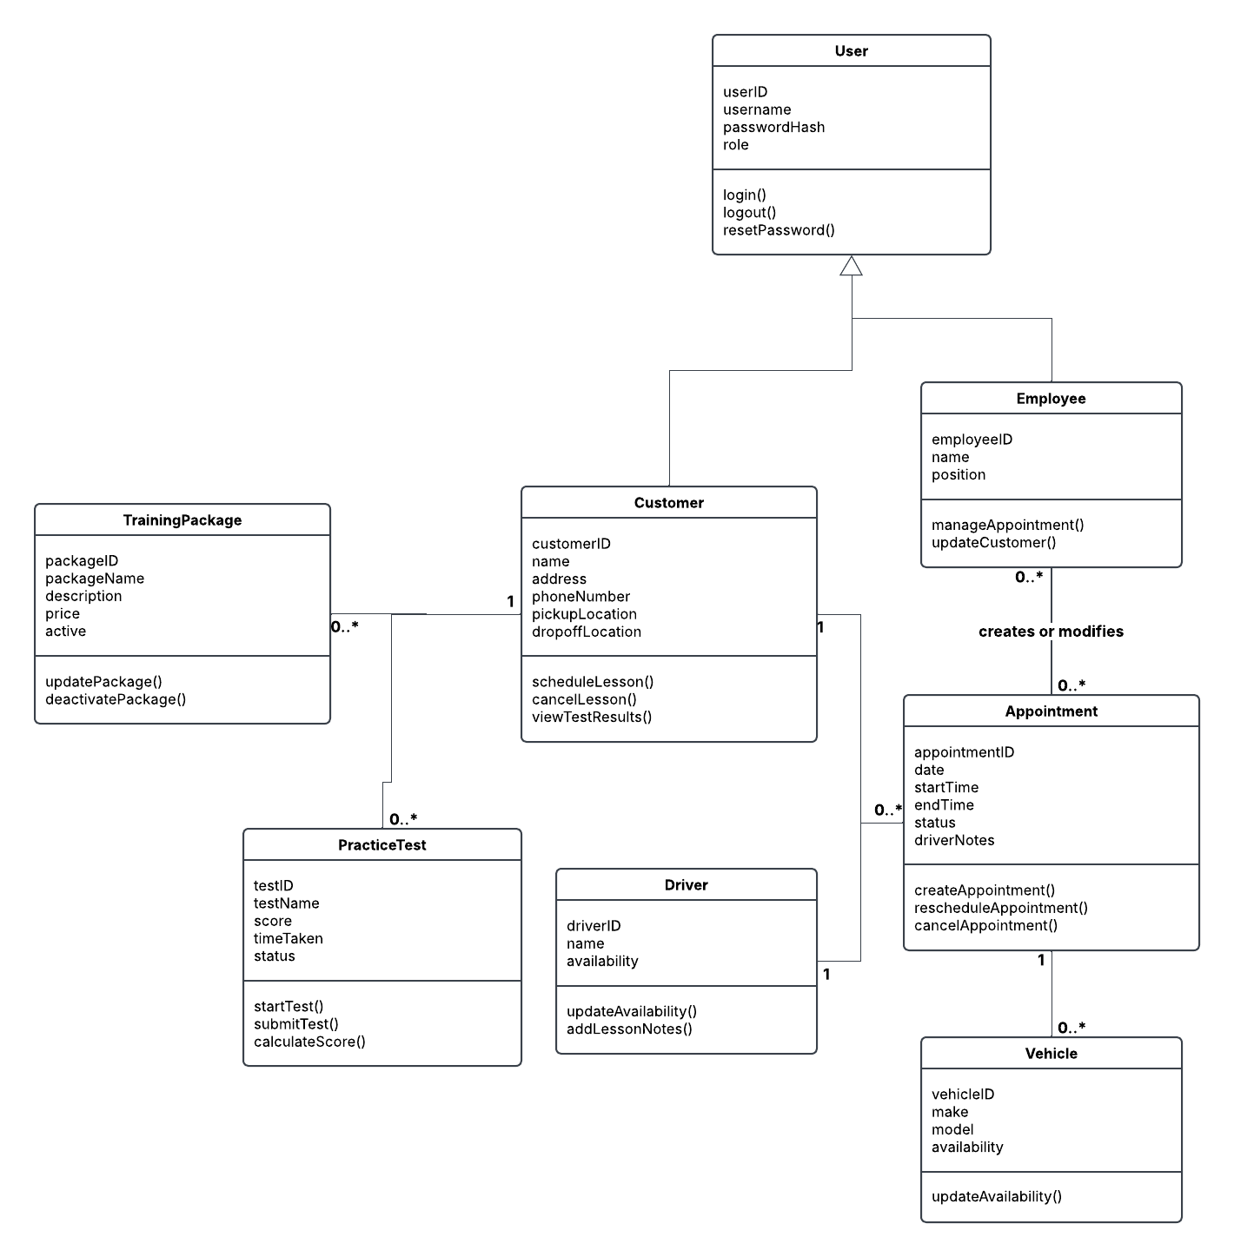

Technical Requirements
The Driver Pass system will be web-based and preferably hosted through a cloud service. This will allow customers and employees to access the system using a computer or mobile device without needing to install additional software. Users will need a device with a web browser and an internet connection to access the system. Users will need a device with a web browser and an internet connection to access the system. Driver Pass employees will also need computers to manage customer information, appointments, and training packages.

The system will require a database to store customer accounts, appointment information, practice test results, training packages, drivers, and vehicles. This database will need to be connected to the website so information can be updated and accessed when needed. For example, when a customer schedules a driving lesson, the system will need to check the availability of drivers, vehicles, and appointment times before saving the appointment.

Since DriverPass prefers a cloud-based system, the cloud provider would handle much of the server infrastructure, including storage, backups, and system availability. The system will also need security measures to protect customer information and control access based on users’ roles. Customers should only have access to their own information, while employees will have different levels of access depending on their role and responsibilities.

The development team will need tools to create and maintain the website, database, and scheduling functions. The system will also need to receive updates from the DMV so DriverPass can keep its practice tests and training information up to date. Users will need to be connected to the internet to make changes to the system, although certain reports and information can be downloaded for offline use.

